

W55 Series
Digital Weighing Scale

Operation Manual

Universal Weight Electronics
January 2019 V2

TABLE OF CONTENT

- BEFORE USE FOR THE FIRST TIME

- INTRODUCTION

- PANEL AND KEYBOARD

- INTERNAL FUNCTIONS

- INSTRUCTION TO USE

- DAILY CARE AND MAINTENANCE

APPENDIX:
-ERROR CODES
-COMPUTER COMMAND
-DISPLAY SEGMENT DEFINITION

- BEFORE USE FOR THE FIRST TIME
- Thank you for purchasing an UWE product, please read this instruction carefully before start using. You shall find the following items inside the box:

W55 indicator x 1
Switch power adaptor x 1
Operation manual x 1
Platform (when purchase as complete scale) x 1

If you don’t find all the items as described above, please contact your dealer for further assistance.

- When equips with a platform, place the scale in a stable environment and adjust the adjustable feet to a level position by referring to the bubble level
- The indicator/scale is equipped with rechargeable battery, please charge it until the charging indicator turns green to ensure the best battery performance
- Always use factory supplied power adaptor for charging purpose, an unapproved power adaptor may shorten the battery life and further damages the electronic components
- Warm up the scale for 15 minutes before use for the first time
- Make sure the capacity and division setup on the display when switching on is the same as the data plate
- Avoid to use the scale when the environment is with strong wind, vibration and strong magnetic field
- Use it within the recommended temperature range and avoid wet environment
- Recharge the battery immediately when battery status indicator starts flashing
- Use damp cloth to clean the scale if necessary, excessive moisture is prohibited
- When not using, switch off the power and keep the scale in a dry and cool place

- INTRODUCTION
SPECIFICATION
Model No. | W55
LCD Digits | W55 - 5 1/2 digits
Input Voltage | -15mV ~ +15mV
Input Sensitivity | 0.9μV/e (Legal Approved: 1/10000)
Non-Linearity | 0.01% of Maximum Capacity
Load Cell Excitation Voltage | DC 5V
A/D Conversion Type | Δ-Σ Delta-Sigma 24 bits
A/D Internal Resolution | 1,000,000 Counts
A/D Conversion Rate | 10 times/second
External Resolution | Legal Approved: 1/10000  Non-approved: 1/30000 (Recommended)
Power-on Zero Range | ±10% of Max
Zero Range | ±2% of Max
Tare Range | Full Range Tare
Weighing Units | Kg, g, lb, PCS
Power Source | External AC Adaptor: AC100~240V, DC9V/0.6A  Built-in Rechargeable Battery:  W55/W75: 6V/4Ah
Operating Environment | -10 ~ 40ºC Non-condensed. R.H.≦ 85%

- PANEL AND KEYBOARD

PANEL
W55
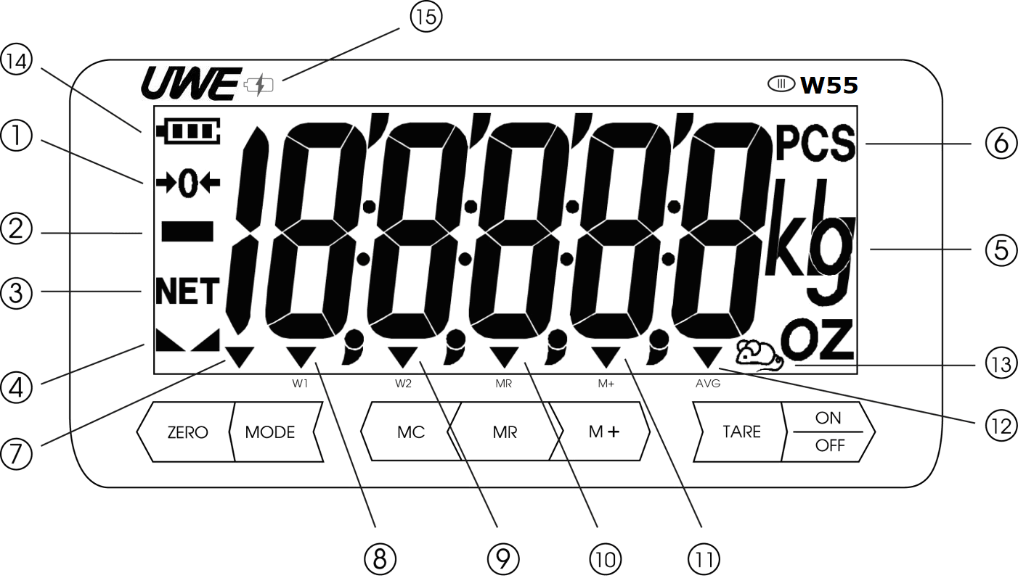

- ZERO INDICATOR
This sign appears when scale is at zero weight status.

- NEGATIVE INDICATOR
This sign appears when weighing result is below true zero

- NET INDICATOR
This sign appears when tare function is engaged and weight shown is the net weight.

- STABLE INDICATOR
This sign appears to indicate the scale is at its equilibrium status.

- WEIGHING UNIT
This indicates the weight unit which the scale is currently measuring:
A metric unit of kg or g can be set.
An imperial unit of lb can be set.

- PIECE COUNTING FUNCTION
This sign appears when scale is in piece counting mode.

- PRESET TARE INDICATOR
This sign appears when a preset tare value is entered and engaged.

- W1
This indicates the scale is set with dual range, and the weight is within the first range.

- W2
This indicates the scale is set with dual range, and the weight is within the second range.

- MR
This indicator appears when value shown on the display is the total saved value.

- M+
This indicator appears when memory contains data.

- AVERAGE FUNCTION
This indicator appears when digital motion filtering function is engaged.

- ANIMAL WEIGHING FUNCTION
This sign appears when scale is in animal weighing mode, which the scale is now operating at maximum motion filtering level.

- BATTERY STATUS
This indicates the power level of the rechargeable battery, and should be charged immediately when the sign starts flashing to prolong the time of rechargeable battery.

- CHARGING STATUS
Red light indicates AC power is supplied and charging is in process.
Green light indicates charging completed

KEYBOARD
 | Press this key to turn on the scale, or press and hold this key to turn off the scale
 | - 1. Press this key to manually set the display value to zero, please refer to specification for manual zero range  2. Press this key to increase the value under internal setup mode
 | - 1. Press this key to tare the weight off from the platter  2. Press and hold this key to enter Pre-Tare setup  3. Press this key to right shift under internal setup mode
 | - Press this key to switch weighing unit from metric to imperial(when this unit is enabled) and to piece counting
 | Press this key to save the weighing result to memory
 | Press this key to recall the total accumulated weighing results from memory
 | Press this key to clear the data saved in memory
- INTERNAL FUNCTION
Because of metrological legislation, accessing to some internal functions is limited to authorized person only when this unit is set to legal for trade. DO NOT try to open the scale or manipulate with the hardware seal when the unit is metrological approved. Please contact your dealer for more information. All internal functions are listed below, some are restricted for dealers only.
DISPLAY | FUNCTION SETTING | ACCESS CONDITION
F 0 | Zero tracking range | Dealer only when LOCKED
F 1 | 1. Analog to digital offset value  2. Function key test | Open
F 2 | 1. LCD segment check and software version information  2. Adjusting backlight brightness | Open
F 3 | Scale configuration setup | Dealer only when LOCKED
F 4 | Auto power off | Dealer only when LOCKED
F 5 | Transmission protocol for RS-232/RS-485 | Open
F 6 | 1. Digital motion filter  2. Animal weighing | Open
F 7 | Transmission mode & data format for RS-232/RS-485 | Open
F 9 | Auto tare | Open
F 16 | Turning on/off real time clock | Open
F 17 | Time and date setup | Open
F 18 | Buzzer sound | Open
F 19 | High resolution verification mode | Dealer only when LOCKED
F 20 | Manufacturing site gravity value setup | Dealer only when LOCKED
F 21 | Final destination gravity value setup | Dealer only when LOCKED
F 38 | Backlight timing | Open
F 100 | Reset to factory default | Dealer only when LOCKED

FUNCTION DEFINITION AND SETUP
- Press and hold TARE and press ON/OFF, display shows F1
- Use TARE (next) or MR (previous) to scroll through the internal setting menu, and press MODE to enter the setting.
- Use ZERO in sub-setting menu to scroll through available options. Press MODE key to confirm and exit.
- Press ZERO and display will show SAVE. If setting was changed, user can either press MODE for yes to save the changes made or press ZERO for not to save the changes.
CAUTION: BEFORE LEAVING THE INTERNAL SETTING, ALL CHANGES MUST BE SAVED OTHERWISE THE SCALE WILL STILL FUNCTION UNDER THE OLD SETTING.

Offset Value & Function Key Test (F1)
Under this function scale will show the offset value and be able to check the function of each key.

LCD Segment Check and Backlight Adjustment (F2)
Under this function all segments and indicators will be in flashing mode as well as backlight for user to check if function properly.
Press ZERO to adjust the backlight brightness. There are five settings, press MODE to confirm setting. Backlight brightness also has 5 level selections for optimal viewing.

Auto Power Off (F4)
Under this function, user can select auto power off timing among 5 minutes, 10 minutes, 15 minutes and 20 minutes or disable the function. There are 5 settings, the numerical digit means the minutes to power off when scale idles. ALL.on means the Scale will never automatically turn off unless manual intervention.
5.oFF -> 10.oFF -> 15.oFF -> 15.oFF -> ALL.on

Transmission Protocol (F5)
Under this function, user can select the transmission interface, speed, mode and format for RS-232 and also the communication protocol.

When display shows F5, press MODE to enter the function
First level selection: | nonE / rS232
Second level selection: | bAUd / ProtL
Selection under bAud: | 2400 / 4800 / 9600 / 19200 / 38400 / 115200bps
Selection under ProtL: | n.8.1 / E.7.1 / o.7.1 / E.8.1
use MODE key to enter, ZERO to change, MODE key to confirm

Terminology:
nonE: no data output
bAud: baud rate
rS232: data output through RS-232
ProtL: transmission protocol

Digital Motion Filter (F6)
Under this function, user can enable digital motion filtering function if the weighing environment is unstable. User also can engage animal weighing function for maximum performance. The scale is equipped with 3 filter speeds:
Filt 0 -> Filt 1 -> Filt 2

Transmission Mode (F7)
Under this function, user can select the transmission mode and data format.

First level selection: | StrM / Manu / CMd / Auto
Second level ForMt: | SEr.1 / SEr.2
use ZERO key to select, MODE key to confirm

StrM: stream mode, data continuous sending when stable (ForMt only has Ser.1 available)

ST, NT, 100.01kg
ST, NT,- 100.01kg
…………………………….

Manu: manual mode, data sends once when manually pressing keypad (press M+ to send one data, press MC to clear memory and send total value)
- When format is set at Ser.1-
Press M+ to send single data (as Ser.1 ForMt), and will not print total value.

ST, NT, 100.01kg
ST, NT,- 100.01kg
…………………………….

- When format is set at Ser.2-
Press M+ to send single data, press MC to send total value (as Ser.2 format)
S/N WEIGHT UT
1 100.02 kg ←press M+ to print single data
2 99.01 kg
3 1210.05 kg
4 10.12 kg L
…………………………
---------------------------------
Sum 9876.10kg ←press MC to print total value
CMd: command mode, data sends when receiving command from computer (READ/ZERO/TARE/NTGS..)
When receiving READ command, indicator will only transmit Ser.1 format.
All other commands will not trigger the data transmission but changing the mode (ZERO/TARE/NETGS)
NOTE:
- When tare function is not engaged, net weight equals to gross weight, so RS-232 will transmit data in NET status.
- When Command Mode is selected in F7, GROSS status will be transmitted under NTGS command.
ST, NT, 100.01kg ←net weight
ST, NT,- 100.01kg
US, GS, 1000.01kg ←gross weight

Auto: automatic mode, data sends once when weighing result stables
- When format is set at Ser.1-
Indicator will automatically send single weighing result when display stables and over 20e, it does not support to print total value.
ST, NT, 100.01kg
ST, NT,- 100.01kg
US, GS, 1000.01kg
………………………………

- When format is set at Ser.2-
Indicator will automatically send single weighing result when display stables, press MC to clear memory and print total value (as Ser.2 format)
S/N WEIGHT UT
1 100.02 kg ←automatically send one weighing result when display stables
2 99.01 kg
3 1210.05kg
4 10.12 kg
………………………….
----------------------------------
Sum 9876.10kg ←print total result when MC is pressed

- When Real Time Clock function is enabled
When indicator is set at rtC.on, date and time information will be included in the RS-232 data stream:
When F7 is set at Ser.1
2015/04/25 10:30:21 ST, NT, 100.01kg
2015/04/25 10:30:39 ST, NT, 210.00kg

When F7 is set at Ser.2
2015/04/25 10:31:21
S/N WEIGHT UT
1 100.02 kg
2 99.01 kg
------------------------------------
Sum 199.03 kg

Printer Selection (F8)
Under this function, user can select the peripheral which the scale will be connected to.
PC for computer -> tEC for Toshiba TEC printer -> ArGoX for Argox printer -> tSC for TSC printer -> SH-24 for 24 columns Dot Matrix printer

Auto Tare & Automatic Continuous Tare (F9)
Under this function, user can enable or disable auto tare function of the first weight, or the consecutive loads place on the platter.
Tr.on (auto tare first weight) -> tr.Cnt (auto tare consecutive loads)-> tr.oFF (auto tare off)

Turning On/Off Real Time Clock (F16 Optional)
Under this function, user can turn on or off real time clock function.
rtC.on -> rtC.oF

Time and Date Setup (F17)
Use this function to setup year, month and date as well as time in 24 hours format.
- display shows Y=XX
- Press ZERO for increasing and TARE to change flashing digit, and press MODE to confirm and entering the next setting
- Display shows M=XX, press ZERO for increasing and TARE to change flashing digit, and press MODE to confirm and entering the next setting
- Display shows d=XX, press ZERO for increasing and TARE to change flashing digit, and press MODE to confirm and entering the next setting
- Display shows H=XX, press ZERO for increasing and TARE to change flashing digit, and press MODE to confirm and entering the next setting
- Display show M=XX, press ZERO for increasing and TARE to change flashing digit
- Press MODE to confirm to complete the setting

Buzzer Sound (F18)
Under this function, user can select buzzer sound on or off.
Sd.on -> Sd.oFF

Backlight Timing (F38)
Under this function, user can select when to turn off backlight.
There are 5 settings, bL.on for always on, bL.oFF for always off and bL.X means the backlight will automatically turn off after X seconds when scale idles.
bL.5 -> bL.10 -> bL.15 -> bL.on -> bL.oFF

INSTRUCTION TO USE
The W55 series are equipped with user friendly functions, including preset tare, manual tare, auto tare, automatic continuous tare, simple counting and memory plus functions. It also comes with interfaces including RS-232 and RS-485 for data output and 4 channel relay output for controlling purpose. Furthermore, the gravity compensation in the internal function also allows user to calibrate the weighing result correctly without involving actual mass.
Before start weighing:
- Make sure load cell cable is connected to indicator
- The scale is placed on a solid surface
- Use adjustable feet and referring to the bubble level to make sure scale is in a level position
- Power on the scale and wait for the counting down
- Scale is in zero weight status and display showing zero indicator and stable indicator
- If Zero indicator is not on, press ZERO to set the display to zero
- If zero weight status cannot be obtained, re-install the platter again
- If stable indicator is not on, check the environment and relocate the scale in a stable environment

WEIGHING UNIT SELECTION
Press MODE to switch between metric, imperial and piece counting mode.

TARE FUNCTION SETTING
This indicator equips with auto tare, continuous tare (please refer to F9 of internal setting) and manual tare.
- If auto tare function is enabled, the first weight being placed on platter will be automatically tared
- If continuous tare function is enabled, each weight being placed on platter will be automatically tared
- If manual tare is needed, place the load/container on the platter first and press TARE to tare off the weight. After weight is tared, NET indicator will appear indicating the weight showing on display is net weight
- If preset tare is needed, press and hold TARE and display will show PrE.Tr and enter preset tare value setup
- Use TARE to shift the flashing cursor and ZERO for increment to adjust the preset tare value
- When desire value is entered, press MODE to confirm and save the change
- Scale will exit the function and return to normal weighing mode while NET indicator and PT indicator appears
- The ZERO indicator points out the negative value shown means the platter is at zero weight status
- When the goods is placed on the platter with a positive value shown, this indicates the actual weight of the goods

How To Clear Tare Function (auto tare, automatic continuous tare, manual tare, preset tare)
- To clear auto tare, remove the initial weight/load from the platter and NET indicator will turn off. Press ZERO to return to zero weight status if ZERO indicator does not appear
- To clear continuous tare, remove all loads from platter and NET indicator will switch off. Press ZERO to return to zero weight status if ZERO indicator does not appear
- To clear manual tare, remove everything from platter and press TARE, the NET indicator will turn off. Press ZERO to return to zero weight status if ZERO indicator does not appear
- To clear preset tare, press and hold TARE to enter preset tare setting, set all value to zero and press MODE to confirm cancelling. Please make sure scale is not engaged in any kind of tare before proceed to modify the preset tare value

MEMORY FUNCTION
How To Save A Weighing Result To Memory
- Place a load on the platter and result will show on the display
- Wait the Stable signal appears then press M+
- Weight result is now saved to memory and M+ indicator appears indicating memory contains data
- Remove the load and scale will return to zero weight status
- Put on another weight and press M+ to save the next weight

NOTE:
Memory plus function can be temporary switch off if needed, particularly when the weighing result does not need to be saved and requiring print out only. To disable memory plus function, press and hold M+ and display shows ACC.on, press ZERO to select between ACC.on and ACC.oF and press MODE to confirm.

How To Recall A Weighing Result From Memory
- Press MR at anytime to recall the total result saved in memory, MR indicator appears indicating the value shown on display is total result
- Result will remain on display for a short while before return to the previous screen

How To Clear Weighing Result From Memory
Follow the below steps to clear saved data from memory after all transactions completed.
- Press MR first to recall the total saved result from memory, the MR indicator will appear
- Press MC immediately to clear the memory and M+ indicator will off indicating there is no data in the memory

PIECE COUNTING FUNCTION
This indicator equips with simple piece counting function, please follow the below procedure to enable the function and sampling method.
- Indicator is on and both Zero indicator and Stable indicator are on
- Press MODE until display shows PCS as weighing unit on the display
- Press MR and display shows S: 10, this means count 10pcs of the same item to put on platter for sampling the average unit piece weight
- If 10pcs is not needed, continue to press ZERO and display will show S:20, S:50, S:100, S:200, S:500 and S:1000. When the ideal quantity is reached, press MODE to confirm and put the sample quantity on platter
- The display will return to normal weighing mode with PCS indicator showing the scale is now in piece counting mode.
- Remove the load and put new batch, display will show the batch quantity.
- If display shows a value while platter is empty, press ZERO to zero off the weight.
- If new sampling is needed, press and hold MR to start new sampling by following step c to d.

NOTE:
- If scale detects the total weight of samples on the platter are smaller than 20d, the PCS sign will start flashing as warning. Press ZERO key to change the sampling quantity setting or add more samples until the signal is off.
- If scale detects the unit piece weight of the sample is smaller than minimum unit weight, the PCS sign will start flashing as warning (unit piece weight must not small than 0.5d). It is recommended using smaller capacity scale for this sampling.
- When PCS sign flashes, sampling process can still in process but might result errors.

CHECK WEIGHING FUNCTION
This indicator is equipped with check weighing function which allowing users to set high and low limits to quickly checking the weight of each product within the range or not.
- Indicator is on and both Zero indicator and Stable indicator are on
- Press and hold MODE until display shows CHK W
- Press MODE to enter and display shows Hi for hi limit setting, press ZERO for value increment and TARE for shifting digits. Press MODE to confirm and entering low limit setting
- Display shows LoW, press ZERO for value increment and TARE for shifting digits. Press MODE again to confirm and entering alarm setting
- Display shows bEEP first and then showing bb-no, press ZERO for options bb-Go, bb-H.L, bb-Hi, and bb-Lo
Display | Description
bb-no | No alarm for any weighing result
bb-Go | Alarm activates when weighing result falls within the range
bb-H.L | Alarm activates when weighing result falls outside the range
bb-Hi | Alarm activates when weighing result higher than the range
bb-Lo | Alarm activates when weighing result lower than the range

NOTE:
- Check weighing function can be engaged under any weighing unit including piece counting mode. When the weighing unit is PCS and check weighing mode is activated, display will show CHK P for checking piece.
- If check weighing limits have been programmed before, display will show PrEV for resuming the previous setting or not when entering the setup. Press MODE to confirm using the previous setting or ZERO to set new limits.
- To temporary disable check weighing function, press and hold MODE again to enter check weighing setup and press ZERO when displays CHK W

- HOW TO CONNECT RS-232 (D-sub 9 pin female connector)
Refer to F5 and F7 in Internal Function to setup transmission protocol
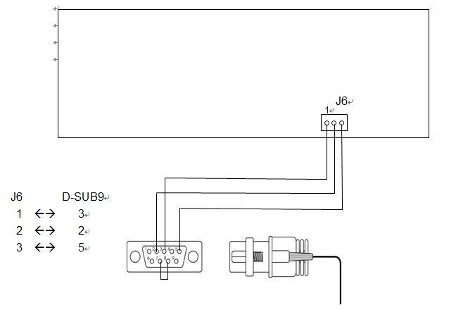
Indicator end

Pin 7 & 8 Shorted internally
Pin Assignment (PC end)
 | 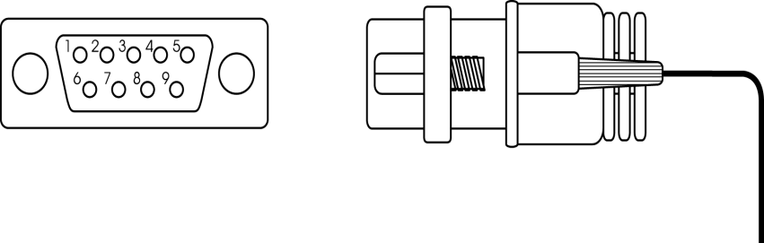
  Pin | Assignment
  1 | DCD
  2 | RXD
  3 | TXD
  4 | DTR
  5 | GND
  6 | DSR
  7 | RTS
  8 | CTS
  9 | NC
PC end
Scale end

2
2
3
3

Only need to connect Pin2, 3 and 5
5
5

HOW TO CONNECT RS-485 (D-sub 9 pin male connector)
Pin | Assignment
1 | A(+)
2 | B(-)
3
4
5
6
7
8
9

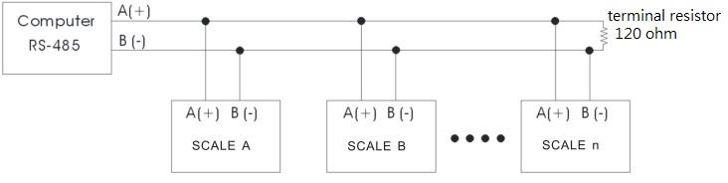NOTE: when connect with multiple devices, parallel a 120ohm resistor in the last device

- DAILY CARE AND MAINTENANCE
-Do not attempt to open the indicator or try to repair except authorized technicians only
-Always aware of the using environment to avoid excessive moisture and extreme temperature
-Use original factory supplied switch adaptor for charging only
-Recharge the battery immediately when the battery level indicator starts flashing to avoid permanent damage to the rechargeable battery
-Do not put anything on the platter after weighing completes to avoid causing damage to the load cell
-If cleaning is needed, use damp cloth to clean the surface
-If cleaning agent is needed, please use mild detergent and avoid excessive water. Do not use any chemical or alcohol for cleaning purpose
-If you are uncertain about how to properly maintaining your scale to the optimal condition, please contact your dealer for further assistance

APPENDIX:
ERROR CODES
ERROR CODE | DESCRIPTION | SOLUTION
Err 0 | Flash memory accessing error | Change MCU, contact dealer for assistance
Err 1 | A/D accessing error | Check A/D, contact dealer for assistance
Err 2 | Load cell wiring error | Check load cell wiring pin assignment
------ | No load cell signal/load cell reading error | Check load cell and connection

COMPUTER COMMAND
- PC→”READ” command
R | E | A | D | CR | LF
52H | 45H | 41H | 44H | 0DH | 0AH

Indicator→sending data string

 |  | ， |  |  | ， | …… | ， |  |  | CR | LF

HEADER 1 HEADER 2 weighing data (8 digits, including negative sign and decimal point) UNIT

- PC→”ZERO” command
Z | E | R | O | CR | LF
5AH | 45H | 52H | 4FH | 0DH | 0AH
Indicator→executing zero command

- PC→”TARE” command
T | A | R | E | CR | LF
54H | 41H | 52H | 45H | 0DH | 0AH
Indicator→executing tare command

- PC→”NTGS” command
N | T | G | S | CR | LF
4EH | 54H | 47H | 53H | 0DH | 0AH
Indicator→executing net weight/gross weight switching

- PC→”MODE” command
M | O | D | E | CR | LF
4DH | 4FH | 44H | 45H | 0DH | 0AH
Indicator→executing weighing mode switching

Data Format：Ser.1 (strictly only weighing result, such as ST, NT, 100.01 kg)
ST, NT, 100.01 kg
ST, NT,- 100.01 kg
US, GS, 1000.01 kg
…………………..
…………………..

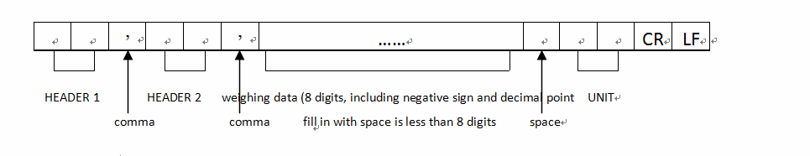

HEADER 1  OL: overload ST: stabled  US: unstable | HEADER 2  NT: net weight  GS: gross weight | UNIT  kg, g, lb, t

Ser.2 (print Total)
S/N WEIGHT UT
1 100.02 kg ←press M+ to print single data
2 99.01 kg
3 1210.05 kg
4 10.12 kg
……………………………..
--------------------------
Sum 9876.10 kg ←press MC to print total value

NOTE: weighing unit on print result reflects the weighing unit been engaged in operation

1 | 2 | 3 | 4 | 5 | 6 | 7 | 8 | 9 | 10 | 11 | 12 | 13 | 14 | 15 | 16 | 17 | 18 | 19
S | / | N |  |  |  | W | E | I | G | H | T |  | U | T |  |  | CR | LF
 |  | 1 |  |  |  | 1 | 0 | 0 | . | 0 | 2 |  | k | g |  | G
 |  | 2 |  |  |  |  | 9 | 9 | . | 0 | 1 |  | k | g |  | L
 |  | 3 |  |  | 1 | 2 | 1 | 0 | . | 0 | 5 |  | k | g |  | H
 |  | 4 |  | - |  |  | 1 | 0 | . | 1 | 2 |  | k | g |  | -

DISPLAY SEGMENT DEFINITION
